

Home visits
Home visits are at the discretion of the GPs and are usually for those patients who are housebound or have significant health issues. Should you require a home visit, please call 01633 251133 option 3 before 12pm. A clinician will then triage your request.
When we are closed
When the practice is closed and you need urgent medical help in a life-threatening emergency call 999 immediately. If it is not life-threatening, contact NHS 111 Wales by calling 111 or visit the website using the QR code below.

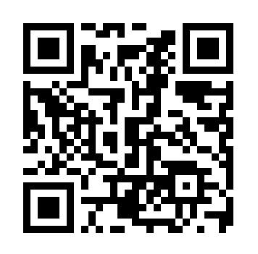

Mental Health Crisis Support
If you, or someone you know, is experiencing a mental health crisis, you can now call NHS 111 and select option 2 for 24/7 access to crisis mental health support. The service is still provided by your local NHS mental health trust –

How to register at the practice
The quickest way to register at the practice is to download the forms from our practice website or collect from you nearest branch..

You must live within the practice area which is shown on the website. If you are unable to use the website, please contact the practice for information about how to register.

-6-

Appointments & accessing practice services

To request an appointment with a GP, please visit our practice website. We encourage patients to complete an Accurx submission between 8:00am and 10:30am for routine issues, if the surgery reaches capacity this may at times close earlier. After 10:30am, the surgery will manage urgent issues only.

Please use the QR code below to submit an e-Consultation via Accurx

Accurx is the quickest and most efficient way to access the care or service you need.
If you are unable to access the website, please call the surgery on 01633 251133, and our reception team will be happy to assist you.

For routine nurse appointments, please contact the surgery via telephone.

You can also use Accurx to:
- Submit admin requests (e.g., sick notes, letters)
- Access self-referral options, which will provide links and guidance for services such as physiotherapy, GDAS, and many more

The practice website contains all the relevant practice information that you are likely to require. It is the quickest way to access the services you may need.
Threats of violence or abuse of our staff
Our staff work hard to provide you with the best possible service. Please treat them with the courtesy and respect they deserve. We operate a zero-tolerance policy and may refuse to provide services to individuals or those accompanying individuals who are violent, threaten violence, commit or threaten to commit a criminal offence

-7-

Patient Information Leaflet
St David’s Clinic is a partnership providing NHS Services under an NHS General Medical Services Contract over 3 sites.

St David’s Clinic – NP20 2LB
St Brides Medical Centre – NP10 8UX
The Gaer Medical Centre –NP20 3GX

Telephone No. 01633 251133
Email address: enquiries.w93054@wales.nhs.uk

Opening hours Monday-Friday
Site | Open | Close
St David’s Clinic | 08:00am | 06:30pm
Gaer Medical Centre | 08:00am | 06:00pm
St Brides Medical Centre | 08:00am | 05:30pm

Please note doors Close at St David’s Clinic at 6pm, phones lines are open until 6.30pm

For more information on the surgery scan the QR code below

-1-
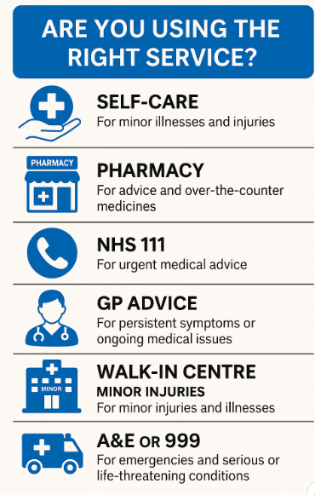
Complaints & Feedback
We are committed to providing high-quality care and services. If you are unhappy with the care or treatment you have received, we encourage you to let us know so we can learn from your experience and make improvements. Most concerns can be resolved quickly by speaking with a member of our team at the time.

If you would like to make a formal complaint, you can do so in writing, by phone, or by email, enquiries.w93054@wales.nhs.uk. We follow the NHS Wales “Putting Things Right” process, which ensures your concerns are taken seriously and handled fairly. More information about raising concerns in NHS Wales is available at
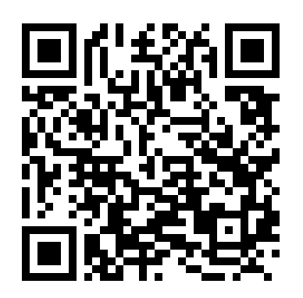

-8-

Prescriptions/repeat prescriptions
Your GP will issue a prescription if they determine that medication is necessary. If you are on regular medication, you may be eligible for repeat prescriptions, which can be requested in the following ways-Please note we DO NOT take requests over the phone:

- Tick the items you need on your repeat prescription slip and post it in the dedicated box outside St David’s Clinic (main site).
- Email your request to:- prescriptions.w93054@wales.nhs.uk Please Include:
- Your full name
- Date of Birth
- List of medication you require
- Preferred pharmacy, or confirm if you wish to collect directly from St Davids Clinic.
- You can request your medication using the NHS App (preferred method) – simply scan the QR code below to get started
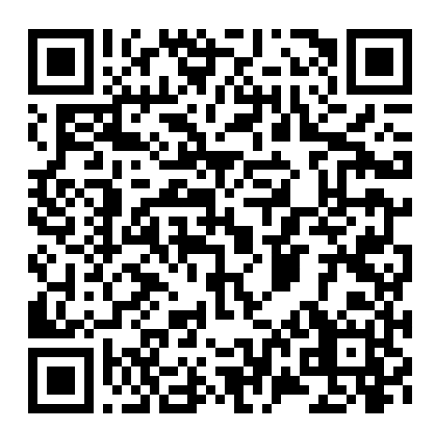
- Vulnerable patients can ask their preferred pharmacy to submit medication requests directly to the surgery. Please speak to your pharmacy for more details

IMPORTANT UPDATE: Changes to Prescriptions – Please Read
From 9th September 2025, we moved to Electronic Prescribing.
You can nominate a pharmacy with your chosen pharmacy directly or with us.
From 1st October 2025, prescription requests and collections will no longer be accepted at St Brides or The Gaer.
All requests must go through St David’s Clinic only.
-4-

-3-
Prescription Processing Times
- Collecting from St David’s Clinic: Please allow 72 hours
- Collecting from a pharmacy: Allow 5 working days-Please nominate.
Note: These timeframes exclude weekends and bank holidays-please check times with your pharmacy
Prescription Queries

If you have a question about your prescription, please call the surgery and select Option 2 on the phone menu.
Lines are open between 12:00pm and 4:00pm, Monday to Friday.

Urgent Prescription Requests

Only medications deemed as urgent by our pharmacist or Duty GP will be processed same day and are to be sent to your nominated pharmacy via EPS.

Requests for late-ordered medication(s) are not considered urgent.

It is the patient’s responsibility to ensure that repeat prescription requests are ordered in time. If you forget to obtain repeat medication, contact your pharmacy for assistance under the Urgent Provision of Repeat Medication Service who may be able to supply you with a further cycle of previously repeated medicine.

Access the full list of pharmacies and their services by scanning the QR code
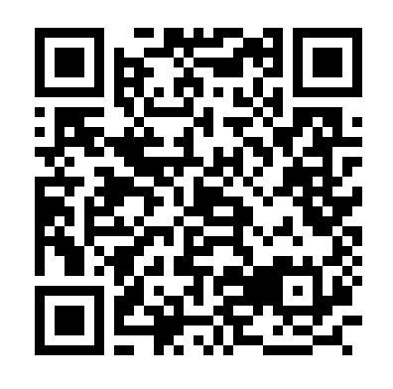
We aim to process urgent requests promptly but cannot guarantee same-day turnaround. A text notification will be sent once the request has been processed.

-5-

Services we provide

Along with routine appointments, the practice offers the following services:

- Immunisations – The nursing team administers vaccines for both adult and child immunisations.
- Cervical smear testing – For women aged 25 – 65. These tests are undertaken by the nursing team.
- Chronic disease management – We hold a range of clinics to help our patients to manage their long-term medical problems including asthma, diabetes, hypertension, kidney disease and heart disease.

From time to time, other services may be available such as raising awareness of a particular disease or condition. We will advertise this information on our website and within the practice.

For more health information and support, scan the QR code to visit ABUHB



Patient data
All clinical and administrative staff have an ethical as well as a legal duty to protect patient information from unauthorised disclosure and in accordance with UK GDPR.

-3-

The Practice Team
Partners:
Dr R Ganesan – Senior Partner
Dr R Davies
Dr V Anand
Dr B Ferrao
Dr J Naughton
Dr P Speirs

Salaried GPs:

Dr A Davies
Dr A McGarrigle
Dr K Williams
Dr C Jenkins
Dr D Loverock
Dr S Manasani
Dr A Jiang
Dr M Sharabash
Dr Huda Kaleem
Dr Seema Sethi

Nursing Team:

Mrs S Chapman
Mrs J Macalast
Ms J Lewis
Ms S Szura
Mr J Canning
Ms A Buchanan
Ms B Danaher
Ms T Brown-Wellington

Other healthcare staff:

Mr T Wilson -Physiotherapist
Mr T McKillen – ACP
Ms L Forlemu Physician Associate
Mrs R Duffield-Pharmacist
Mrs C Yip – Pharmacist
Mrs A Lian – Pharmacy Technician
Ms A Hodges-Pharmacy Technician

Management Team:

Mrs C Podmore-Practice Manager
Ms S Rogers-Deputy PM
Mrs H Dearden – Office Manager
Mr V Celso – Operations Manager

-2-

1

